Under **Custom | Extensions** in the admin section, you have a new component called “OGData”. For setting it, you click on the name and it appears the following window:

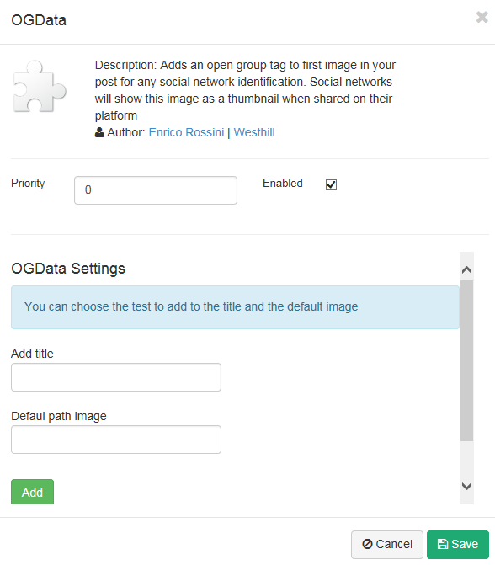

You find two setting:

* **Add Title** is a text that the blog platform add automatically in the og:title tag
* **Default path image** is the image that social networks use when the post doesn’t have an image. You have to insert a full path (as <http://myenglishnotes.co.uk/Custom/Themes/Standard/images/logo.png>)

Then click on the **Add** button and then click on **Save** button.